﻿APQB Unit 2.1 – GDP and circular flow
- Which of the following is true according to the circular flow model?
- Firms are suppliers in both the product and factor markets.
- Firms are demanders in the product markets and suppliers in the factor markets.
- Households are demanders in both the product and factor markets.
- Households are demanders in the product markets and suppliers in the factor markets.
- The government is a demander in the product market only.
- Which of the following is most likely included in gross domestic product?
- Matt gives his secondhand bicycle to his brother.
- Sal paints his own bicycle.
- Josh buys a new bicycle.
- Mike buys a share of stock in a bicycle firm.
- Daniel bikes to school every day.
- Suppose that personal income is $3,500 billion, personal taxes are $1,000 billion, and depreciation is $500 billion. Disposable income is equal to which of the following?
- $1,500 billion
- $2,000 billion
- $2,500 billion
- $3,000 billion
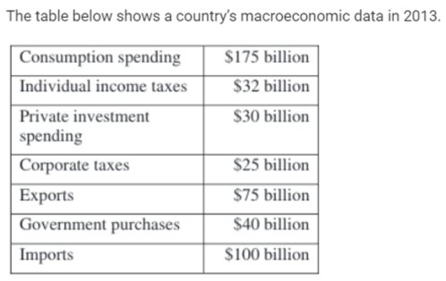
- There is not enough information to answer the question.
- ﻿The country's gross domestic product is
- $220 billion
- $282 billion
- $304 billion
- $309 billion
- $347 billion
- The value of which of the following is counted in the United States gross domestic product?
- Clean air
- Child care a father provides for his child
- An automobile produced in Sweden by a United States firm
- A car produced in the United States and sold in Europe
- Medical services not provided due to preventative health care
- In the circular flow diagram of a market economy, which of the following supplies the factors of production?
- The business sector
- The government
- The household sector
- Financial sector
- The foreign sector
- Which of the following represents a leakage from the circular flow in an economy?
- Consumption spending
- Government spending
- Investment spending
- Unemployment benefits
- Imports
- Which of the following can be considered a leakage from the circular flow of economic activity?
- Investment
- Government expenditures
- Consumption
- Exports
- Saving
- The circular-flow model indicates that final goods are produced by
- firms and sold in the factor markets
- firms and sold in the product markets
- firms and sold in the resource markets
- households and sold in the factor markets
- households and sold in the product markets
- If purchases of education and medical care were counted as investment rather than consumption, gross domestic product would
- not change, because there is no change in total expenditures
- increase, because investment is included in gross domestic product but consumption is not
- increase, because consumption is included in gross domestic product but investment is not
1 | D | 6 | C
2 | C | 7 | E
3 | C | 8 | E
4 | A | 9 | B
5 | D | 10 | A

- decrease, because investment is weighted more heavily than consumption in calculating gross domestic product
- decrease, because consumption is weighted more heavily than investment in calculating gross domestic product.

Free Response Question
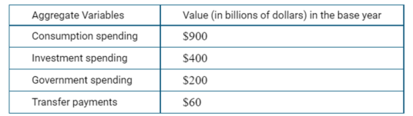
- Use the table below to answer the following questions:
The marginal propensity to save is equal to 0.4 and there are no exports or imports.
(a) Calculate the real GDP in this country. Show your work.
(b) Calculate the marginal propensity to consume. Show your work.
(c) Suppose that the government increases spending from $200 billion to $300 billion.
(i) Calculate the maximum change in real GDP. Show your work.
(ii) Given the change in real GDP in part (c)(i), calculate the maximum level of the new equilibrium real GDP. Show your work.
(d) Suppose that taxes decrease by $100 billion. Will the maximum change in real GDP be larger than, smaller than, or equal to the change in real GDP identified in part (c)(i)? Explain.

Answers
- 900 + 400 + 200 = 1500
- MPC = 1 – MPS = 1-0.4 = 0.6
- =100 x 1/0.4 = 250 billion
Total = 1500 + 250 = 1750 billion
- Maximum change in real GDP will be smaller because only a portion of the extra money will be used for consumption (because of the MPS)

